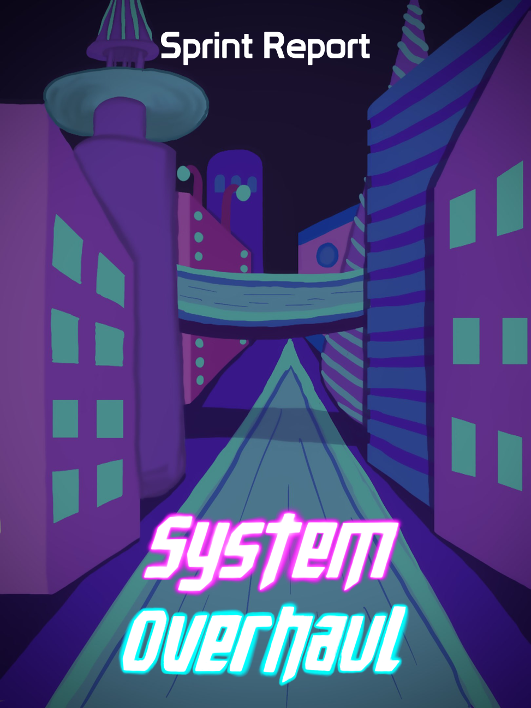





**Table of Contents**

**Previous Week** **2**

Sprint Backlog 2

Review 2

**Next Week** **3**

Sprint Backlog 4

Notes 4

# Previous Week

## Sprint Backlog

| **Tasks** | **Time Needed** | **Responsible** | **Priority** | **Stage** |
| --- | --- | --- | --- | --- |
| Player Jump | ½ hour | Gonçalo | High | Completed |
| Radar Ability | 1 hour | Sheehan | High | Completed |
| Player Health | 1 hour | Gonçalo | High | Completed |
| Melee Enemy | Still Counting | Gonçalo | High | In Progress |
| Ranged Enemy | Still Counting | Sofia | High | In Progress |
| Combine Code  Together | 2 hours | All | High | Completed |
| Switch Weapon | 1½ hours | Sheehan | High | Completed |

All of our objectives were succeeded except both enemies which still need some work, but they are overplanned.

## Review

In the Melee enemy and Ranged enemy tasks we wanted to implement something more complex (even though the basics are working) so it took more time than what was expected and it got delayed, these tasks will be reassigned in sprint 3. Also after putting the code together the player melee attack doesn’t work with the switch weapons and the ranged attack code, this task will be redone in sprint 3.

The rest of the tasks were done successfully and were finished in time.

No tasks were planned from the design part. Nothing was overplanned.

# Next Week

In the “Required for CG & AI” backlog our tasks with higher priority are the following:

| **Tasks** | **Time Estimate** |
| --- | --- |
| Melee Enemies | 3 Days |
| Ranged Enemies | 3 Days |
| Radar Ability | 3 Days |
| Particle System in Projectiles | 1½ Days |
| Friendly NPCs | 3 Days |
| Player Hurt Shader | 2 Days |

In the “Coding” backlog our tasks with higher priority are the following:

| **Tasks** | **Time Estimate** |
| --- | --- |
| Collect Items | ½ Day |
| Checkpoints | 1 Day |
| Combine code | ½ Day |
| Puzzles | 2 Days |
| Upgrades | 2 Days |
| Player Crouching | ½ Day |
| Player Hurt Shader | 2 Days |

In the “3D Models & Animations” backlog the priority of the tasks didn’t change

In the “Docs” backlog the priority of the tasks didn’t change

In the “UI / 2D / Sounds” backlog the priority of the tasks didn’t change

## Sprint Backlog

| **Tasks** | **Time Estimate** | **Responsible** | **Priority** | **Stage** |
| --- | --- | --- | --- | --- |
| Melee Enemies | 2 Days | Gonçalo | High | In Progress |
| Ranged Enemies | 2 Days | Sofia | High | In Progress |
| Puzzles | ½ Day | All | High | Open |
| Collect Chips | ½ Day | Gonçalo | Normal | Open |
| Check Points | ½ Day | Gonçalo | Normal | Open |
| Upgrades | 1 Day | All | Low | Open |
| Player Melee Attack (redo) | 1 Day | Sofia | Urgent | In Progress |
| Combine Code | ½ Day | All | High | Open |
| Particle System in Projectiles | X | Sheehan | Normal | Open |

## Notes